Creating new task – can enter invalid mapping combo, receive error upon create
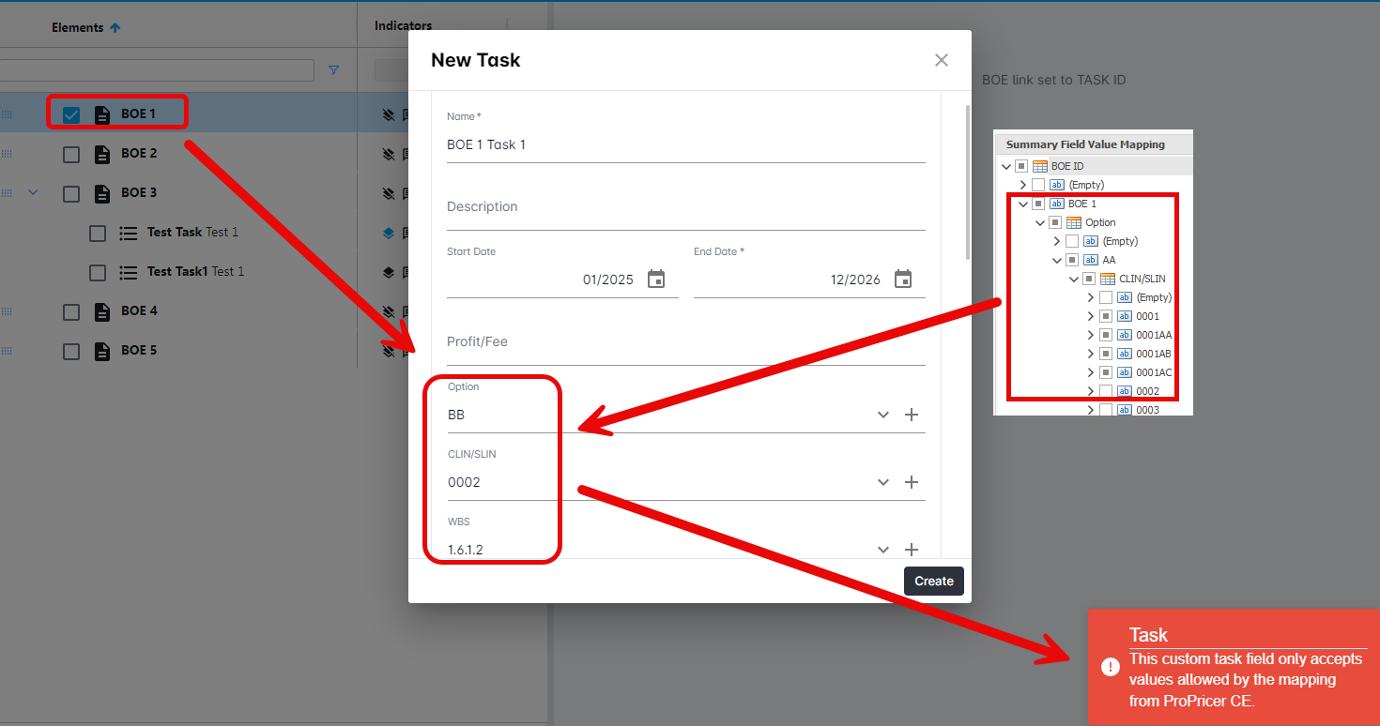
Edit Task – can still enter invalid mapping combo, but receives error symbols that the combo is incorrect prior to hitting the create button.
